# AI For Game Technology – Assignment 7

## Terrain Generation

## The team

Dimitris Christodoulou - 5141761

George Psomathianos - 5405467

## 1.1 Abstract

In this assignment, we explore the Marching Cubes algorithm and its usefulness when creating voxel-based terrain via a density function. We use this algorithm to generate interesting underwater terrain that includes sporadic mountain-like islands. Such islands will be created by huge underwater rock formation and might span in size, from big rocks to huge islands that will include vegetation.

## 1.2 The System

The application is built using Unity 3D 2020.3.9f1. We utilize the GPU by generating the terrain with compute and fragment shaders and Unity’s standard surface shaders. Since the program runs almost exclusively on the GPU, each terrain generation takes less than 2 seconds, depending on the scale of the terrain and the amount of vegetation that is instantiated.

### 1.2.1 High level overview

Our terrain generation system consists, at a high level, of two parts; The evaluation of a density function in the 3D space and the cube marching based on this density function. Those two stages were implemented exclusively compute shaders. The first part will determine how interesting and varied the terrain will be and the second part will generate the actual terrain. For the density function we use noise to initialize the density in each voxel corner and using various functions and methods we manipulate the value. Once the terrain is generated, we use Unity’s surface shaders to color the terrain via a height-based layering approach and finally, we generate vegetation based on random sampling of vertices in a specific layer (the grass layer).

### 1.2.2 Density Function

The density stage runs on compute shaders, thus every thread corresponds to a corner of a voxel. We use simplex noise (Takahashi, n.d.) with Fractal Brownian Motion (Vivo, n.d.) to add octaves and more detail to the noise. Based on the type of terrain we used different functions and methods. For example for the mountains, we used a sinusoid function, whereas for the caves with used modulo to create terraces (nVidia Developer: GPU Gems 3, 2007). Finally for the ground we used domain warping to create more twisted and smooth terrain (Vivo, n.d.).

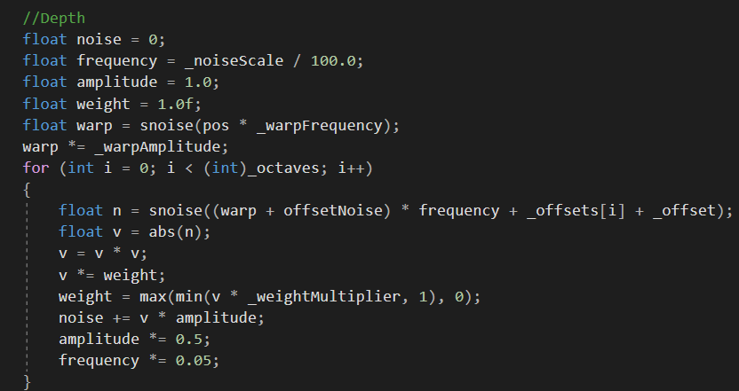

Figure : Example of fbm with domain warping

For each octave we also added an offset, so that to make it less repeated and create more natural noise.



Figure : Function that creates mountain-like terrain.

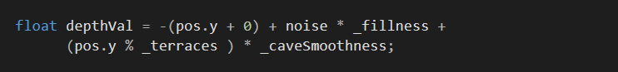

Figure : Function for caves

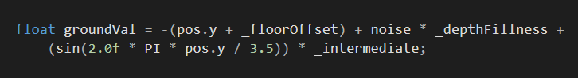

Figure : Function for the ground

We defined specific heights in which only one type of terrain would be active there. Meanwhile, we used linear interpolation in the heights where the terrain changes from one to another with a small margin for a smoother transition.

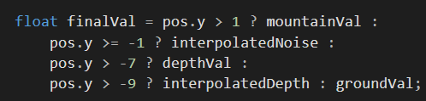

Figure : Final density values including all 3 types of terrain

### 1.2.3 Marching Cubes

### 

For each voxel, there are 8 corners. If a corner has a value greater than an isolevel value then we assign a bit with 1 otherwise with 0. There are 255 cases of possible configurations. Depending on the case there are different polygons that can be created within the voxel.

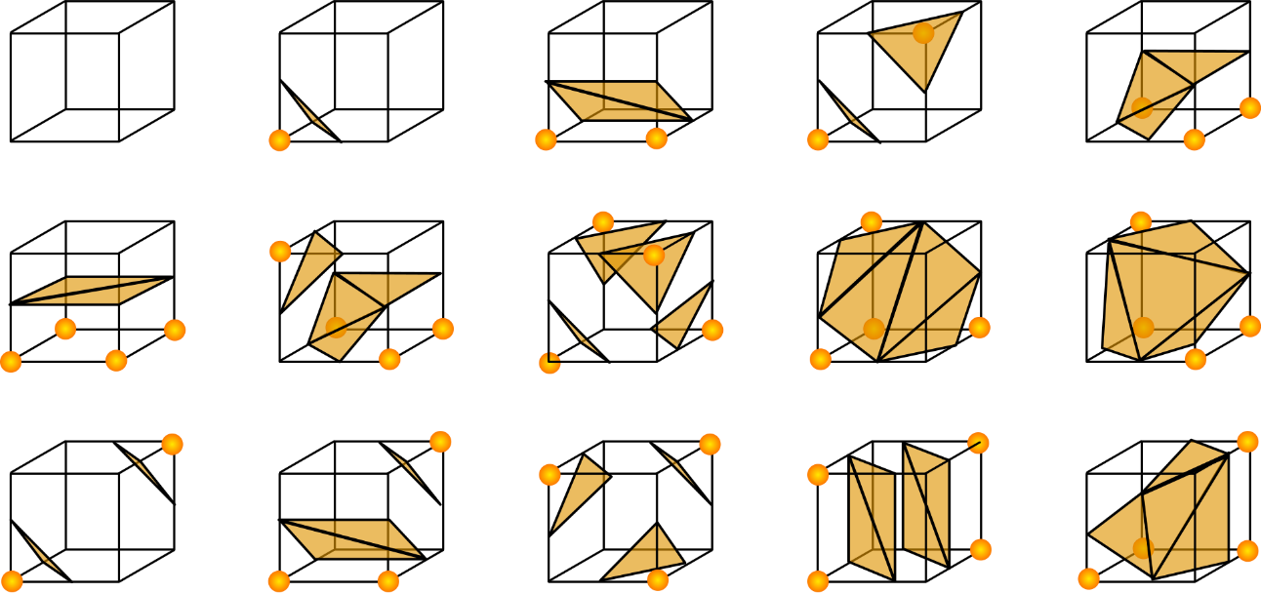

Figure : Examples of possible polygon configurations for the Marching Cubes algorithm

There are 2 intermediate compute shader stages before the actual marching cube shader. We wanted to minimize the CPU usage as much as possible. The problem was that we have to create an array for the vertices’ positions and another for the indices. The arrays values are assigned sequentially and the algorithm is not embarrassing parallel. Furthermore, each voxel can have from zero to five polygons, so we can not know in advance how much memory will this voxel allocate. Since we want to run the whole algorithm in parallel we need to know how many polygons each voxel will have and the offset in the array. For example, if voxel_i starts at the index *j* and has three polygons, then the next voxel should write in index *j + 3 * 3* (each polygon/triangle is defined by 3 vertices, hence the multiplication by 3). In other words, each voxel we need to know how many polygons will be created before. To achieve this, we first computed in a shader the number of polygons each voxel will create based on the case that will be retrieved from the density buffer, then, we calculated the prefix sum of each voxel. The prefix sum algorithm in summary, takes as an input a buffer with V elements (V : number of voxels) and outputs a 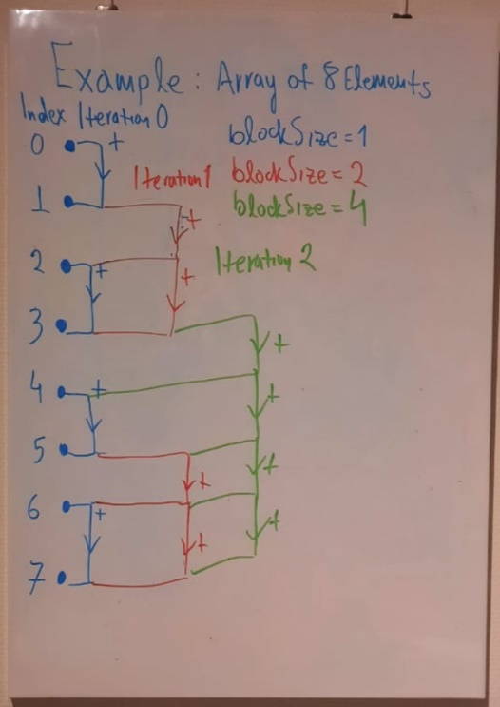buffer of the prefix sum of the input. For example:

Figure : Our algorithm example with array of 8 elements

Input: N[V], Output S[V]

S[0] = N[0]

S[1] = S[0] + N[1]

S[2] = S[1] + N[2]

.

.

.

S[V] = S[V-1] + N[V]

Prefix sum is not as well embarrassing parallel. To make it parallel we dispatch the shader multiple times, where in each iteration we organize the elements in blocks. The block size is increased in each iteration and in the elements of each block the last element of the previous block is being added to them.

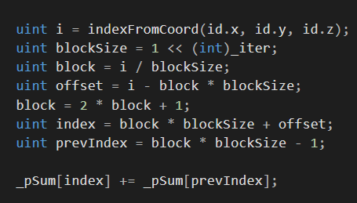

Figure : Compute shader code of prefix sum

Since we have the array of the sum of polygons that will be generated in each index, we can run marching cubes in parallel without fear of overwriting any polygon. Each voxel/thread can write in its index retrieved from the prefix sum.

$NumPolygons=PrefixSum\left[Voxel_{i-1}\right]$

$$Offset=NumPolygons*3$$

We expose different parameters for the terrain generation in order to introduce a large amount of variation in our terrain. Since our scope is to have mainly a large and detailed underwater habitat, we have made it so that the underwater caves scale and smoothness is adjustable, as well as the terracing between each cave layer and the total area of the cave. Since a nice aftereffect of our terrain is that we can also generate large rock formations or islands or coastlines, we also expose parameters that control how large these formations are and if they contain mountain formations or if they are flat. Therefore, we can control how mountainous, steep and tall the area above water is and also how much smooth it is. We can also control if we want multiple mountains above ground or if we want the overall height spread of the terrain to be concentrated in one landmass (i.e., one large mountain).

In order to have more interesting noise as our terrain initialization we used domain warping (Quilez, n.d.). Domain warping or noise distortion is a technique through which we can manipulate any type of noise by adding other layers over it and stretching our initial layer’s points based on the new layers. For this purpose, we also exposed a few parameters to manipulate the warping frequency and amplitude.

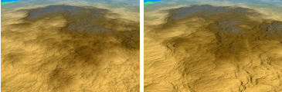

Figure : Left - Terrain without domain warping. We can almost notice how noise was applied to create it. Right - The same terrain, now with domain warping, looks more natural.

After we generate our terrain, we apply some basic shading to it. This shading is based on a simple height layering of our terrain and is done via Unity’s surface shader. We use 4 layers with 4 different shades;

* A cave/underwater layer with a gray shade
* A beach/ground layer with a desaturated yellow shade
* A grass layer with a green shade
* A mountain layer with a brown shade

After we shade the terrain mesh, we generate some simple low-poly vegetation. We generate this vegetation on the grass layer for simplicity. We do this by iterating over the vertices of the mesh in the grass layer and sampling randomly a number of these vertices. Once a vertex is sampled, we take its world location and instantiate a random vegetation prefab from a list of obtained prefabs with a random rotation on the XY plane at the sampled vertices positions. For this part we expose as parameters:

* The starting height of the vegetation (from which height - Y - vegetation will start spawning)
* The ending height of the vegetation (until which height - Y - vegetation will be spawned)
* The probability that a vertex will contain vegetation

We place all generated vegetation under a single game object in order to easily disable and enable the vegetation. This way the user can opt to just view the terrain geometry. The vegetation included in the project was obtained from the Unity asset store and is distributed through the Standard Unity Asset Store EULA. We also included a simple Post Processing volume to simulate the underwater effect.

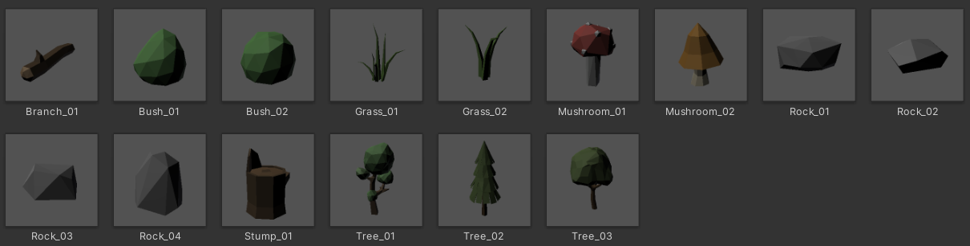

Figure 10: Our list of vegetation prefabs. We instantiate random prefabs out of this list.

## 1.3 Using the terrain generator application

When launching the application a terrain with some preset values is generated. The user can move around with a flycam by using the WASD buttons (W for forward, A for left strafe, D for right strafe and S for backwards). By holding down the Right Mouse Button and moving the mouse the user can rotate the camera freely. By clicking on the “Terrain Settings” button, a UI pops up with a scroll view that contains slider bars that control the terrain parameters. The user can navigate to each section of parameters by clicking the arrow buttons on each section.

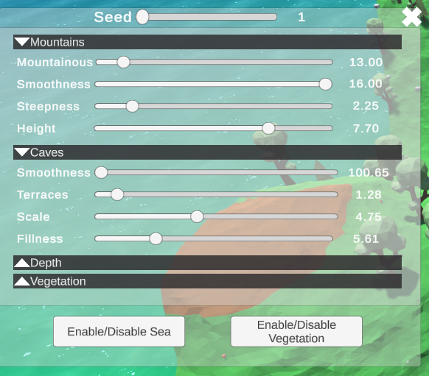

Figure 1: UI

## 1.4 Results

The terrain contains some complex underwater hallways and caves, while in other cases it also includes tall mountains or hills or small valleys between two mountains etc. The voxel geometry is also ideal when creating this kind of terrain, as we can create interconnected layers of corridors and passages. Below we will se examples of each terrain with different parameters:

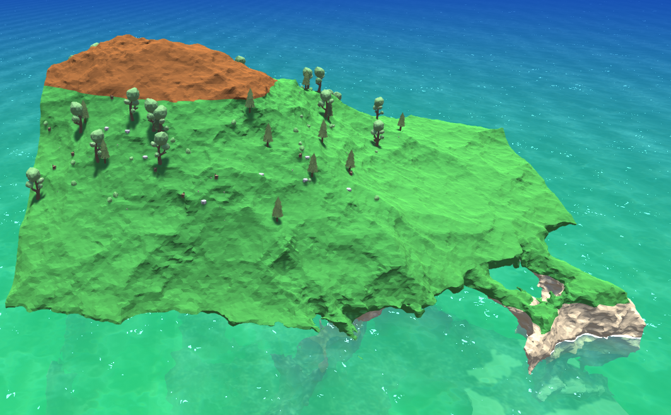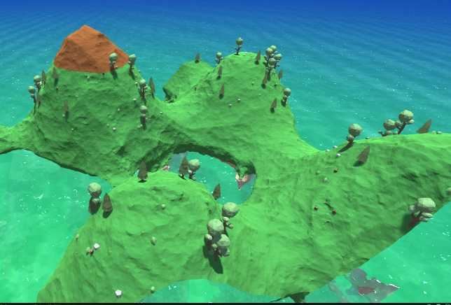

Figure : Moutains with smoothnes = 16, steepness = 2.22, Height = 7.26, Mountainous = 30 (Left) and 10(Right)

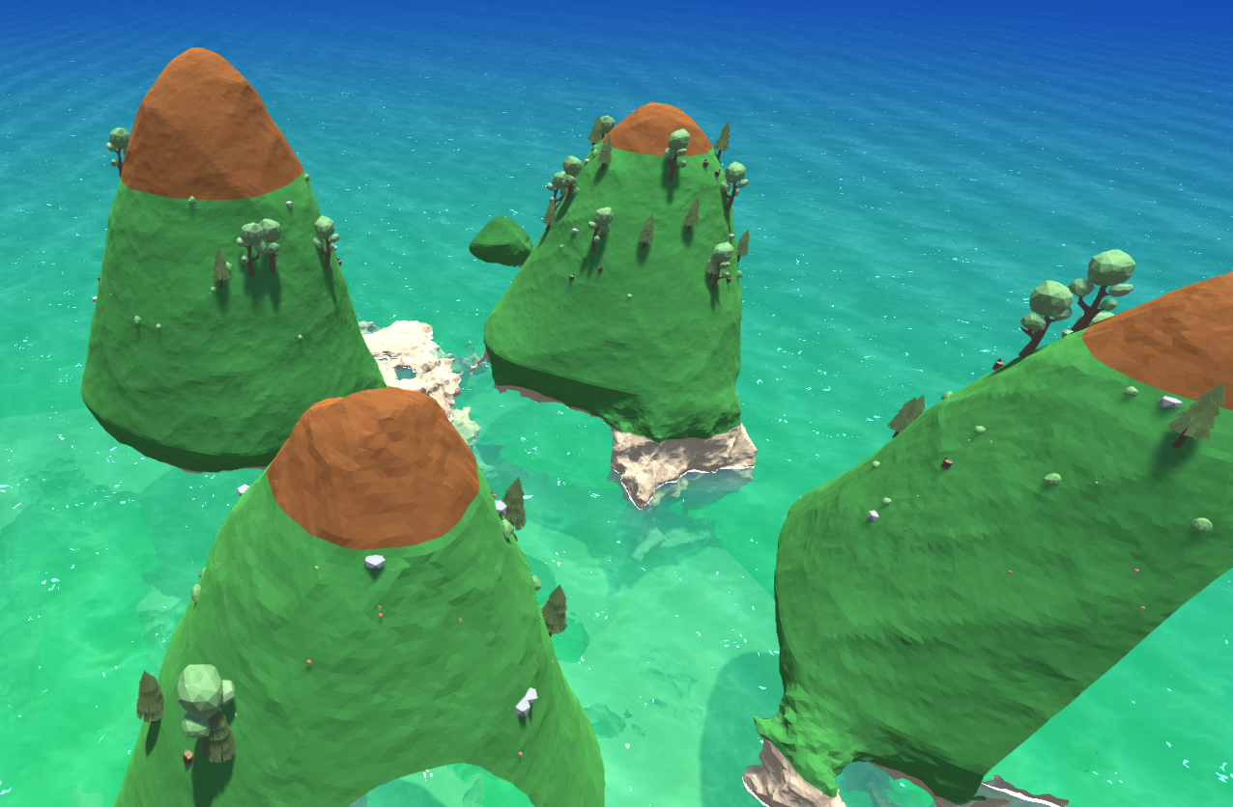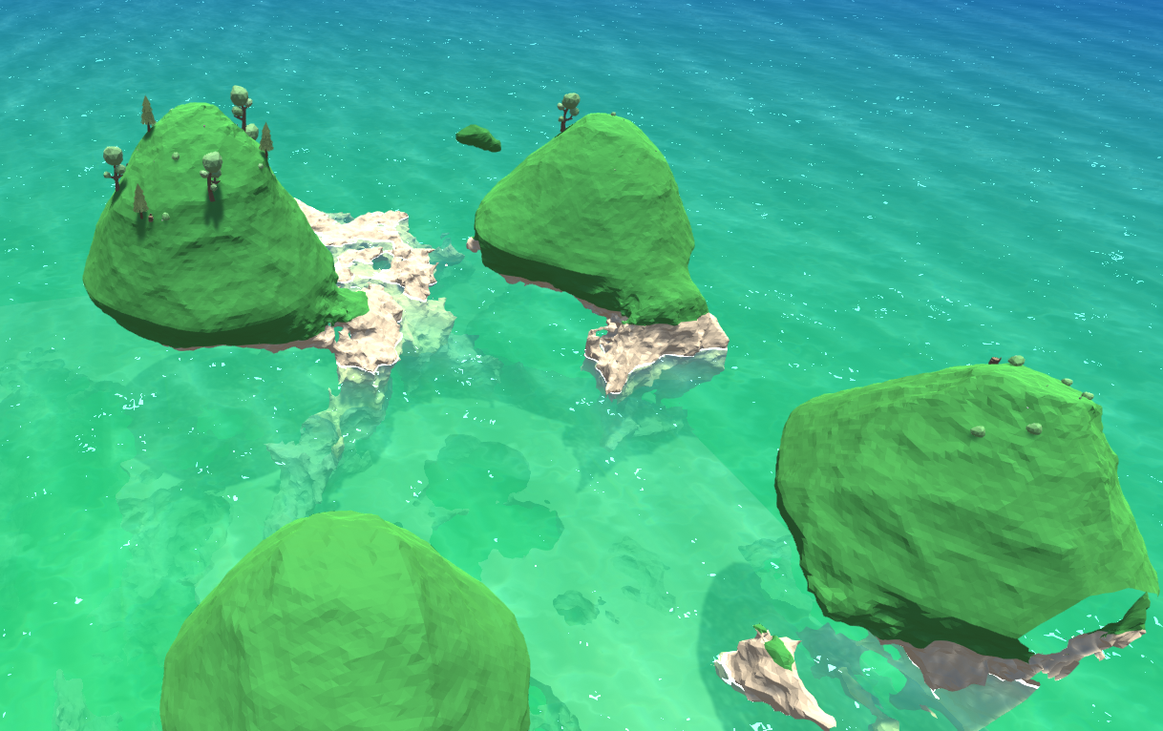

Figure : Moutains with smoothnes = 16, steepness = 4.55 (Left) and 2.77(Right), Height = 5, Mountainous = 10

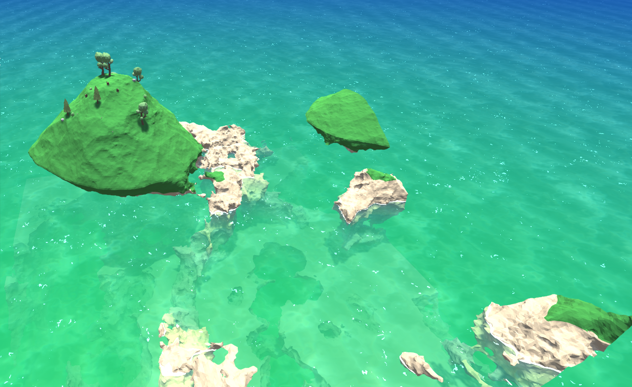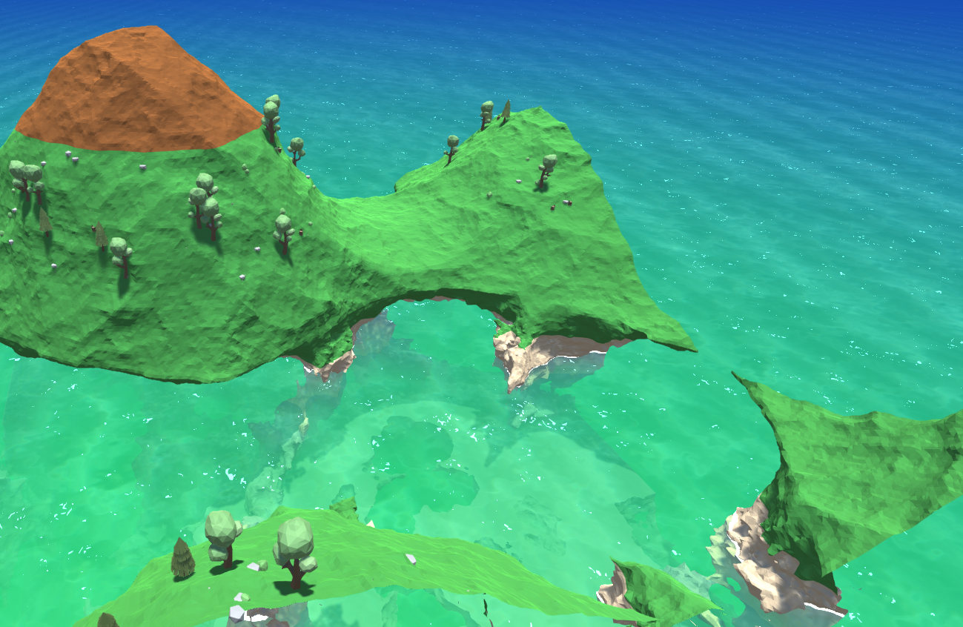

Figure 14: Moutains with smoothnes = 16, steepness =2.62, Height = 4.55 (Left) and 7(Right), Mountainous = 10

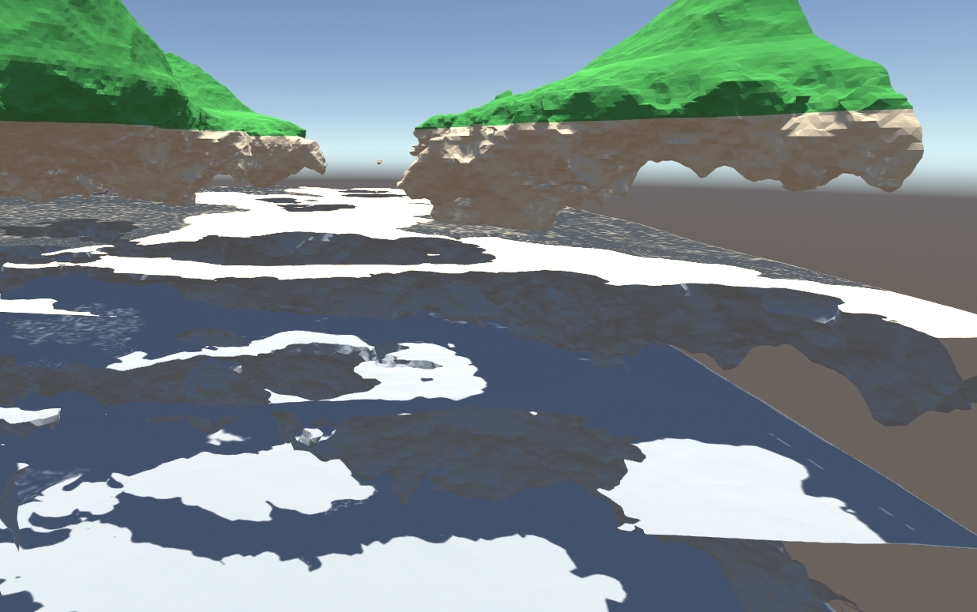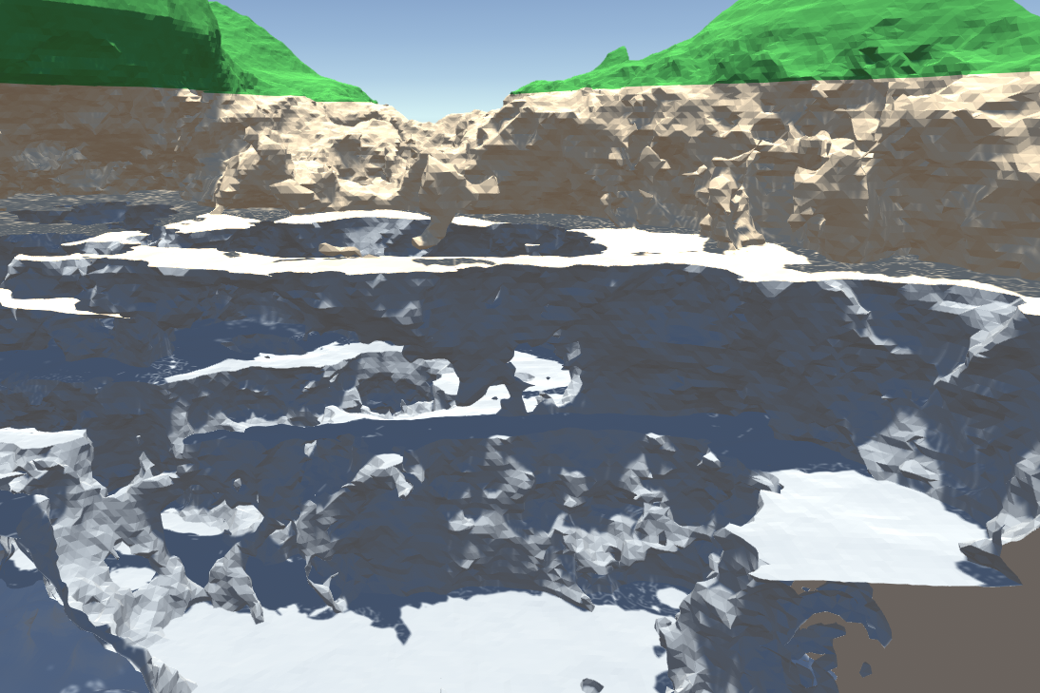

Figure 15:Caves with smoothness 3.55 (Left) and 1.05 (Right), terraces = 3.10, scale = 4.75, Fillness = 7.79

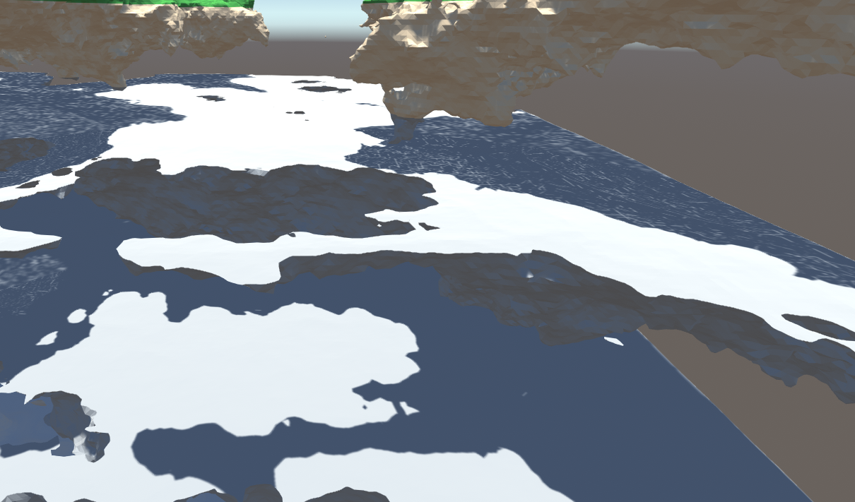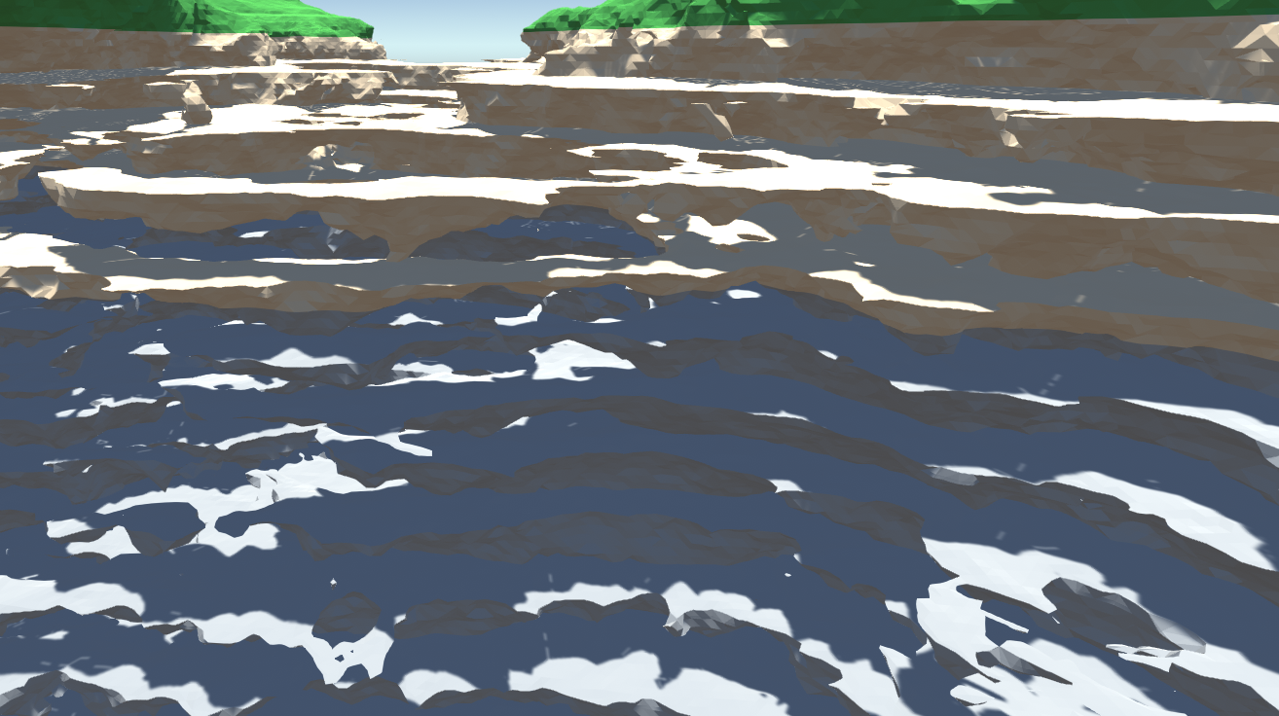

Figure 16: Caves with smoothness 3.74, terraces = 2.55(Left) and 4.55(Right), scale = 4.75, Fillness = 7.79

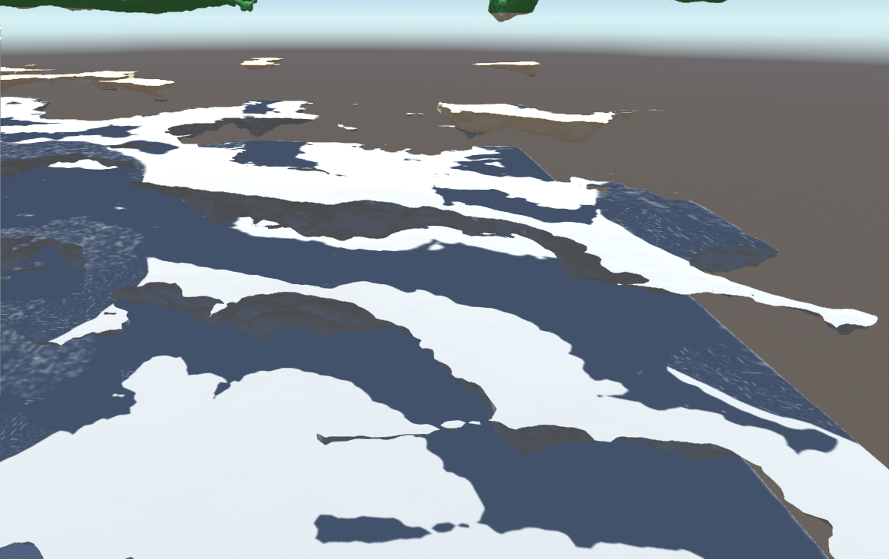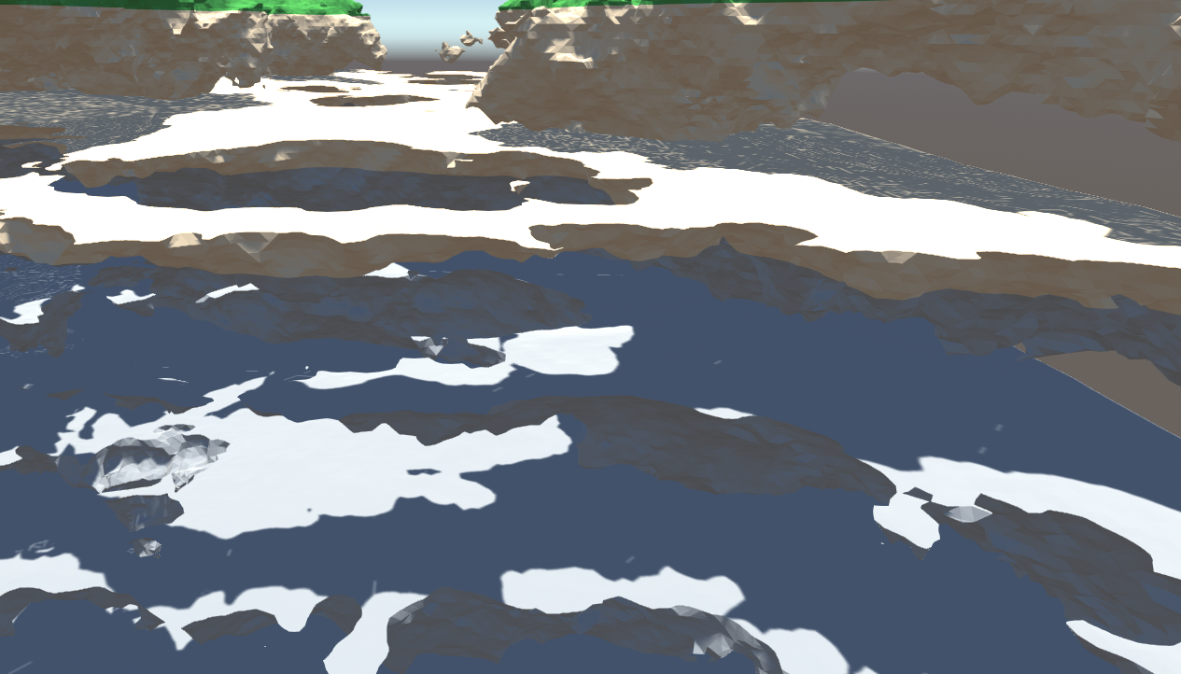

Figure 17: Caves with smoothness 3.74, terraces = 3.52, scale = 4.75, Fillness = 4.74(Left) and 8.04(Right)

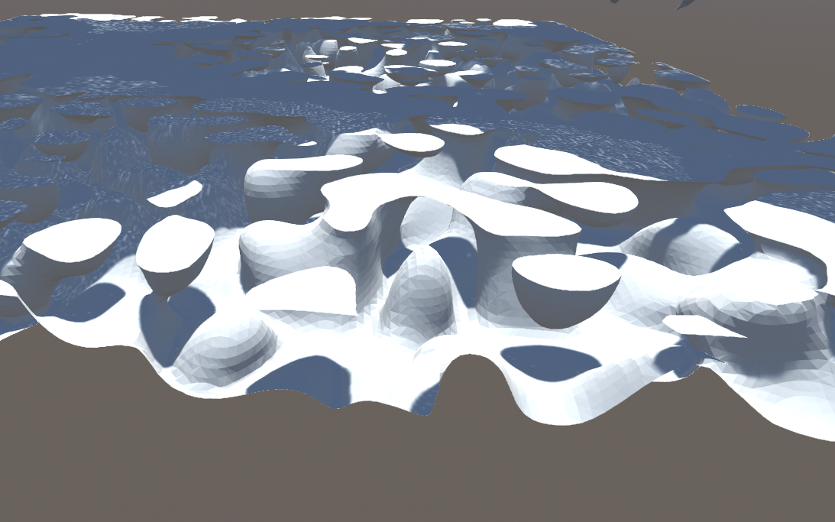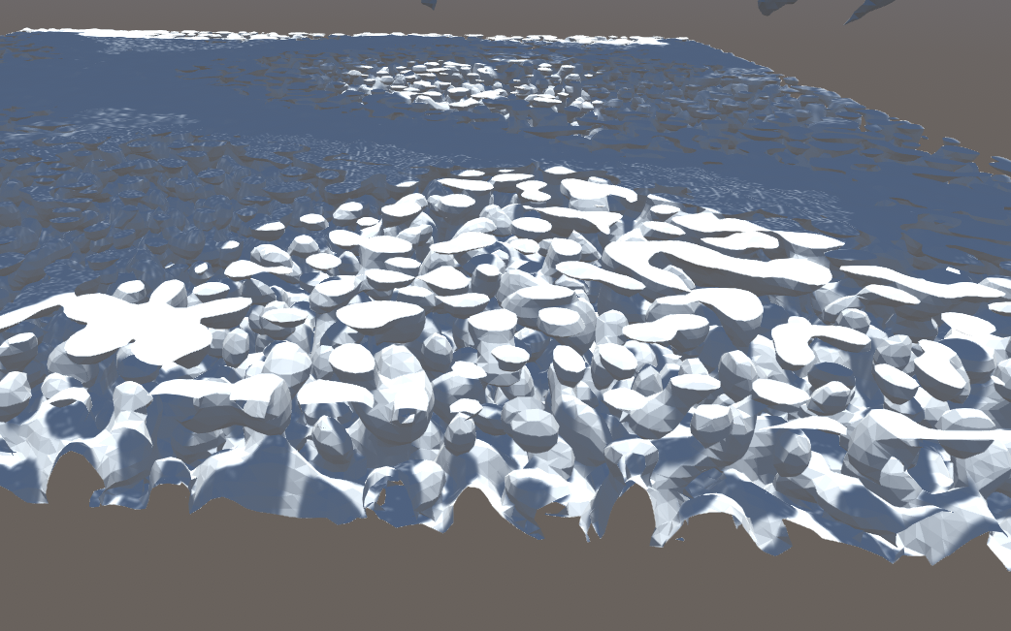

Figure 18: Depth with frequency 0.54 (Left) and 1.41 (Right), amplitude = 8.49, fillness = 100, merge =93.65

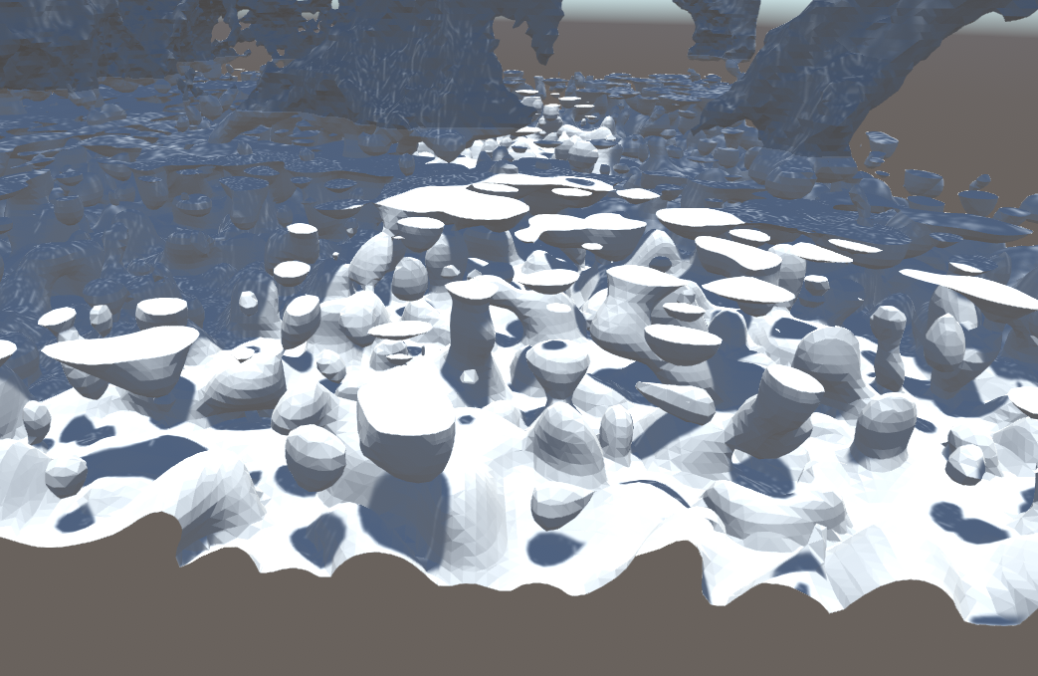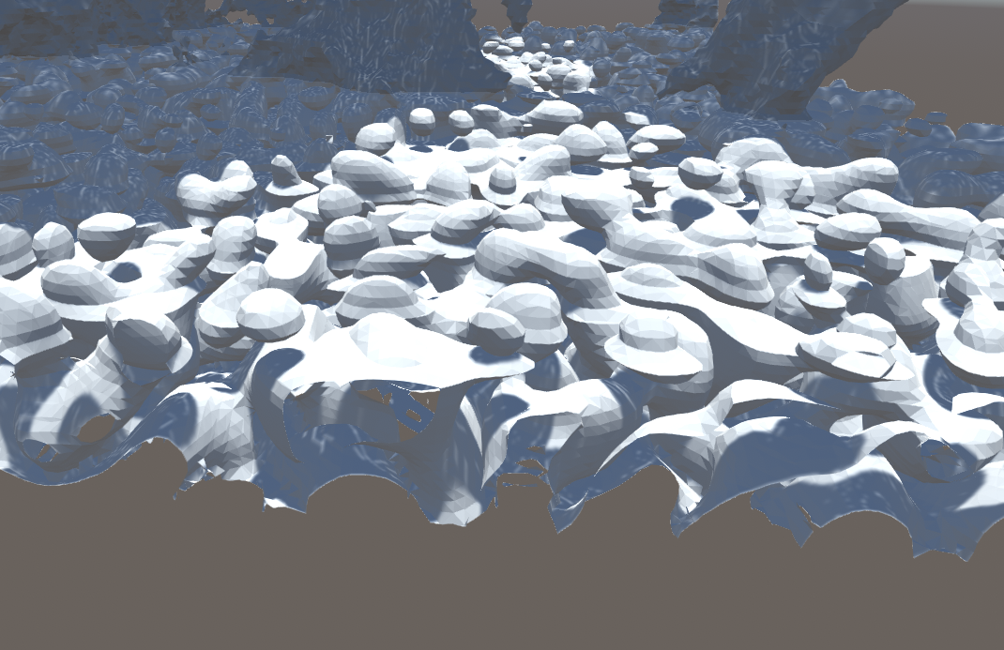

Figure 19: Depth with frequency 0.89, amplitude = 5.52(Left) and 12.14(Right), fillness = 100, merge =93.65

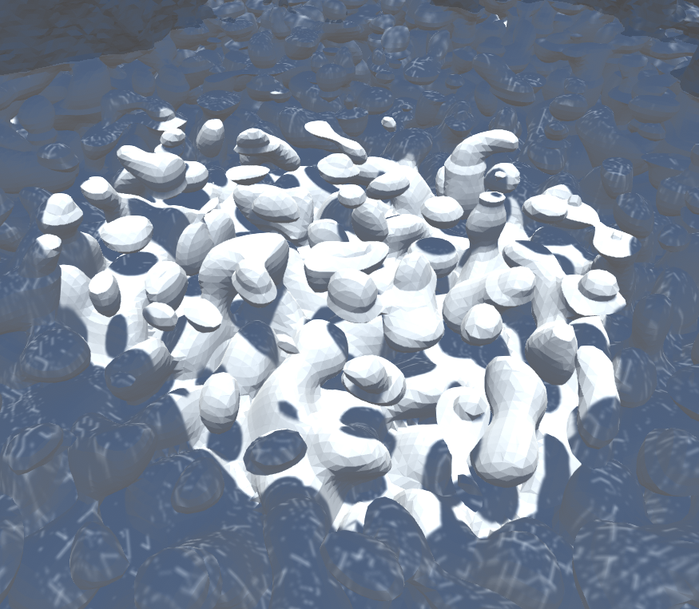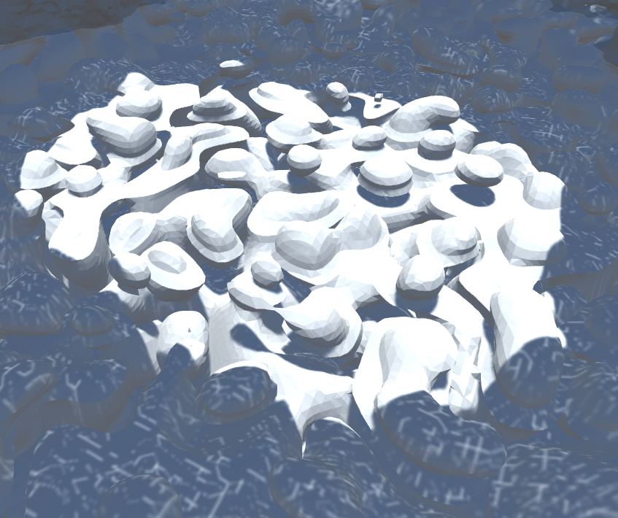

Figure 20: Depth with frequency 0.79, amplitude =11.17, fillness = 127, merge =84.52(Left) and 96.72(Right)

To better observe the depth layer, the cave layer should be simple, to create vacancies and empty spaces.

### 1.5 Conclusion and Limitations

We managed to create a terrain system with multiple layers focused on caves mountain-like islands and underwater depth. The user can tweak the parameters to create the environment they desire. Our terrain is generated fast enough so that the user can receive instant feedback on the parameters’ change and adjust accordingly. Without the vegetation, the terrain generation would be done even faster. However, we did not have enough time to generate the vegetation in the GPU, so there is a bottleneck that slows down the process. Despite that the terrain is generated in less than 1 second.

Furthermore, because of the nature of the marching cubes algorithm, it can generate geometry that floats in the air. Since, we were aiming for underwater and island terrain, the geometry floating is not such a deal breaker. Due to time constraint, we could not solve this. We dedicated most of our time into the coding of the compute shaders and the debugging, since in parallel programming lurk many bugs such as data hazards (prefix sum).

We experimented a lot with many parameters of the density function such as lacunarity, persistence, octaves, scale, noise weight and many more. We exposed only a few of them with different names so that the user can manipulate the terrain with ease. The terrain is with fixed resolution and world size and did not include the feature for the user to change that. This was possible, because we made sure to have zero memory leaks (since the generation is done in every parameter tweak) and recreated all the buffers and arrays. However, the parameters we exposed did not scale well with the increased terrain size. Due to time constraints, we could not fine-tune better the parameters and consider the terrain with varying size. It would be harder for the user to find the parameters to generate a good terrain.

# References

Bruno Torres do Nascimento, F. P. (2018). GPU-Based Real-Time Procedural Distribution of Vegetation on Large-Scale Virtual Terrains. *SBC – Proceedings of SBGames 2018.* Retrieved from https://www.sbgames.org/sbgames2018/files/papers/ComputacaoFull/188348.pdf

*nVidia Developer: GPU Gems 3*. (2007). Retrieved from nVidia Developer: https://developer.nvidia.com/gpugems/gpugems3/part-i-geometry/chapter-1-generating-complex-procedural-terrains-using-gpu

Quilez, I. (n.d.). *domain warping - 2002*. Retrieved from https://www.iquilezles.org/www/articles/warp/warp.htm

Takahashi, K. (n.d.). *Noise Shader Library for Unity*. Retrieved from Noise Shader Library for Unity: https://github.com/keijiro/NoiseShader

Vivo, P. G. (n.d.). *Book of Shaders*. Retrieved from Fractal Brownian Noise: https://thebookofshaders.com/13/